D1_Nihar_84066
ASSIGNMENT 5
1. D1_nihar_84066>select * from ORDERS where Amt>1000;
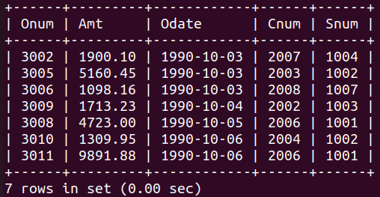

2.D1_nihar_84066>select SNAME, CITY from SALESPEOPLE where comm>.10;
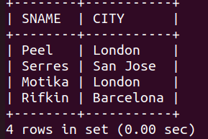

3.D1_nihar_84066>select * from CUSTOMERS where rating>100 or city='Rome';
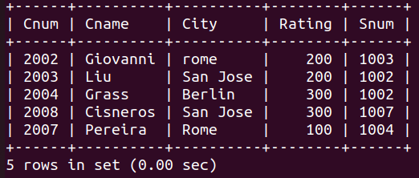

4. D1_nihar_84066>select * from ORDERS where (amt<1000 or not (odate='1990-10-03' and cnum>2003));
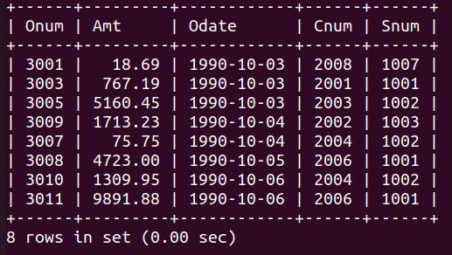

5.D1_nihar_84066>select * from ORDERS where not((odate='1990-10-03' or snum>1006) and amt>=1500);
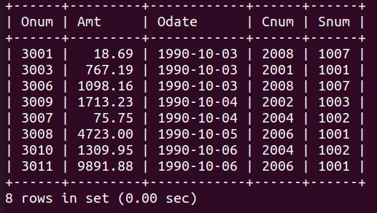

6. D1_nihar_84066>select SNUM, SNAME, CITY, COMM from SALESPEOPLE;
